ACIBADEM MEHMET ALI AYDINLAR UNIVERSITY
INSTITUTE OF HEALTH SCIENCES

DISSERTATION TITLE (MUST BE WRITTEN IN BOLD WITH 14 PT FONT SIZE)

STUDENT NAME SURNAME
M.Sc. THESIS

DEPARTMENT OF …………………….

SUPERVISOR
….. Dr. ……….

SECONDARY SUPERVISOR (IF APPLICABLE)
….. Dr. .....................

ISTANBUL-2024

ACIBADEM MEHMET ALI AYDINLAR UNIVERSITY
INSTITUTE OF HEALTH SCIENCES

DISSERTATION TITLE (MUST BE WRITTEN IN BOLD WITH 14 PT FONT SIZE)

STUDENT NAME SURNAME
M.Sc. THESIS

DEPARTMENT OF …………………….

SUPERVISOR
….. Dr. ……….

SECONDARY SUPERVISOR (IF APPLICABLE)
….. Dr. .....................

ISTANBUL-2024

Department:
Program:
Thesis Title:
Student’s name and Surname:
Date of Defence: …/…/….

This is to certify that I have examined this copy of the master thesis. I confirm that she/he prepared after fulfilling the specified requirements in the associated legislations before the final examining committee whose signatures are below.

Jury Member Title, Name Surname, Signature
(Supervisor of the thesis) University, Department

Jury Member Title, Name Surname, Signature
University, Department

Jury Member Title, Name Surname Signature
University, Department

DECLARATION

I declare that this thesis work is my own work, I had no unethical behavior at any stages from the planning to the writing of the thesis, I obtained all the information in this thesis in accordance with academic and ethicel rules, I cited all the information and comments that were not obtained with this thesis work, and I provided resources in the list of references. I also declare that there was no violation of any patents and copyrights during the study and writing of this thesis.

Date
"Name Surname"
(Signature)

PREFACE AND ACKNOWLEDGEMENT

TABLE OF CONTENTS

DECLARATION iii
PREFACE AND ACKNOWLEDGEMENT iv
TABLE OF CONTENTS v
ABBREVIATIONS AND SYMBOLS……………………………………………vi
LIST OF FIGURES vii
LIST OF TABLES ix
ÖZET 1
ABSTRACT 2
1 INTRODUCTION AND AIM 3
1.1 First level sub heading 1 3
1.1.1 Second level sub heading 2 3

1.1.1.1 Third level sub heading 1 3

1.1.1.2 Third level sub heading 2 3
1.1.1.2.1 Fourth level sub heading 1 3
2 BACKGROUND 4
2.1 First level sub heading 1 4
2.1.1 Second level sub heading 2 4

2.1.1.1 Third level sub heading 1 4

2.1.1.2 Third level sub heading 2 4
2.1.1.2.1 Fourth level sub heading 1 4
3 MATERIALS AND METHODS 5
3.1 First level sub heading 1 5
3.1.1 Second level sub heading 2 5

3.1.1.1 Third level sub heading 1 5

3.1.1.2 Third level sub heading 2 5
3.1.1.2.1 Fourth level sub heading 1 5
4 RESULTS 6
4.1 First level sub heading 1 6
4.1.1 Second level sub heading 2 6

4.1.1.1 Third level sub heading 1 6

4.1.1.2 Third level sub heading 2 6
4.1.1.2.1 Fourth level sub heading 1 6
5 DISCUSSION 9
5.1 First level sub heading 1 9
5.1.1 Second level sub heading 2 9

5.1.1.1 Third level sub heading 1 9

5.1.1.2 Third level sub heading 2 9
5.1.1.2.1 Fourth level sub heading 1 9
6 CONCLUSION 10
7 REFERENCES 11
8 APPENDIX 13
APPENDIX 1 13
APPENDIX 2 14
9 CURRICULUM VITAE 15

ABBREVIATIONS AND SYMBOLS

LIST OF FIGURES

Figure 1. Figure title and explanation 6
Figure 2. Figure title and explanation 7
Figure 3. Figure title and explanation 7

LIST OF TABLES

Table 1. Table title and explanation 8
Table 2. Table title and explanation 8

ÖZET

Tezin Türkçe Başlığı Buraya Yazılmalıdır

Anahtar Sözcükler: Anahtar sözcük 1, anahtar sözcük 2, anahtar sözcük 3, anahtar sözcük 4, anahtar sözcük 5.

ABSTRACT

Tezin İngilizce Başlığı Buraya Yazılmalıdır

Keywords: Keyword 1, keyword 2, keyword 3, keyword 4, keyword 5

INTRODUCTION AND AIM

First Level Sub Heading 1

Second level sub heading 2

Third level sub heading 1

Third level sub heading 2

Fourth level sub heading 1

BACKGROUND

First Level Sub Heading 1

Second level sub heading 2

Third level sub heading 1

Third level sub heading 2

Fourth level sub heading 1

MATERIALS AND METHODS

First Level Sub Heading 1

Second level sub heading 2

Third level sub heading 1

Third level sub heading 2

Fourth level sub heading 1

RESULTS

First Level Sub Heading 1

Second level sub heading 2

Third level sub heading 1

Third level sub heading 2

Fourth level sub heading 1

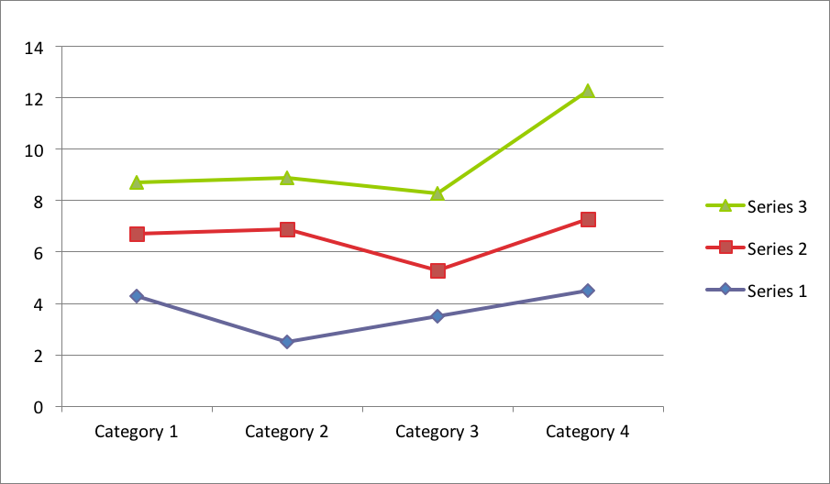
Figure 1. Figure title and explanation

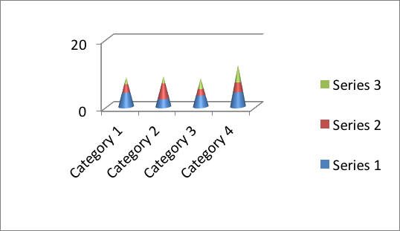
Figure 2. Figure title and explanation

Figure 3. Figure title and explanation

Table 1. Table title and explanation

Table 2. Table title and explanation

DISCUSSION

First Level Sub Heading 1

Second level sub heading 2

Third level sub heading 1

Third level sub heading 2

Fourth level sub heading 1

CONCLUSION

REFERENCES

- Alıcı M. Obez Hastalar Verilen Davranış Modifikasyonu Eğitiminin Etkinliği. M.Ü. Sağlık Bilimleri Enstitüsü, Yüksek Lisans Tezi, İstanbul, 2007 (Danışman: Prof. Dr. R Pınar).
- Bengtsson S, Solheim BG. Enforcement of data protection, privacy and security in medical informatics. In: Lun KC, Degoulet P, Piemme TE, Rienhoff O, editors. MEDINFO 92. Proceedings of the 7th World Congress on Medical Informatics; 1992 Sep 6-10; Geneva, Switzerland. Amsterdam: North-Holland; 1992, 1561- 1565.
- Joint National Committee on Prevention, Detection, Evaluation, and Treatment of High Blood Pressure (JNC). The Seventh report of the Joint National Committee on Prevention, Detection, Evaluation, and Treatment of High Blood Pressure (NIH Publication No. 03-5233). Washington, DC: U.S. Department of Health and Human Services 2003
- Guyton AC, Hall JE. Textbook of Medical Physiology. 1996; Tıbbi Fizyoloji. 9. baskı, Çeviren: Çavuşoğlu H, İstanbul: Nobel Tıp Kitabevleri Ltd. Şti., 2000.
- Appel LJ. Lifestyle modification as a means to prevent and treat high blood pressure. J Am Soc Nephrol 2003; 14 (Suppl 2):S99-S102.
- Gibbs JT, Huang LN, Weiss PJ. (Eds), Hypertension Manner. 10th ed, Tokyo: Mc Graw Hill, 2006.
- Pınar R. Disordered eating behaviors among Turkish adolescents with and without Type 1 diabetes. J Pediatr Nurs 2005; 20(5):383-388.
- Gibbson GG, Skett P. Introduction to Drug Metabolism. 3rd edition. London: Chapman & Hall Ltd, 2001.
- Grolier Inc. Grolier Multimedia Encyclopedia for IBM. Version 13.2 [CD-ROM], Novato 2006.
- Merriam-Webster’s Collegiate Dictionary. 10th ed, Boston: Merriam-Webster, 2003.
- Haas LB. Chronic complications of diabetes. Nurs Clin North Am 1976; 20(3):71-76. In: Lowe LP, Lia K, Greenland P. Diabetes, asymptomatic hyperglycaemia, and 22 year mortality in black and white men. Diabetes Care 1980; 13(8):163-170
- Hatemi H, İlkova H, Yılmaz T.. Endokrin Hastalıklar ve Tedavisi. İstanbul, Nobel Tıp Kitabevleri Ltd Şti., 2000: 543-592.
- Roel JP, Hildebrant CL, Grimm RH. Management of hypertension: Contributions of clinical trials. J Clin Hypertens 2000; 2(3):198-203
- Oğuz A, Bağrıaçık N, İpbüker A. Ülkemizdeki diyabet prevalans çalışmalarına genel bakış. Diyabette Yönelimler 2007:3(1) [Electronic Journal] http://www.medscape.com/viewarticle/474880?src=search,
- Writing Group of the PREMIER Collaborative Research Group. Effects of comprehensive lifestyle modification on blood pressure control. JAMA 2003; 289(16):2083-2093
- Steinke J. Hypertensive Diabetics. in Hypertension Manners. Gibbs JT, Huang LN, Weiss PJ, Eds 10th ed, Tokyo, Mc Graw Hill: 2006, 1033-1098.
- Gutman L. Spinal Cord Injuries: Comprehensive management and research 2nd edition. London: Blackwell Scientific Publications, 1976:353-354.
- Roel JP, Hildebrant CL, Grimm RH. Quality of life with nonpharmacologic treatment of hypertension. Curr Hypertens Rep 2001; 3(6):466-472.
- Yıldız H. Hipertansiyonlu hastalarda yaşam tarzı modifikasyonu. Hemşirelik Bülteni 2002; 21(12):63-68.
- SPSS Inc. SPSS for Windows. Version 11.00, Chicago. 2007.
- T.C. Resmi Gazete. Ölçüler ve Ayar Kanunu. Sayı: 3516, Başbakanlık Basımevi, Ankara. 21 Ocak 1989.
- Whelton PK, Chin A, Xin X, He J. Effect of aerobic exercise on blood pressure: A meta-analysis of randomized, controlled trials. Ann Intern Med 2002; 136(7):493- 503.
- Gibson GG, Skett Paul. Introduction to Drug Metabolism 3rd edition. London: Chapman & Hall Ltd, 2001.

APPENDIX

APPENDIX 1

APPENDIX 2

CURRICULUM VITAE

Personal Information
Name |  | Surname
Place of Birth |  | Date of Birth
Nationality |  | Phone
E-mail

Education
 | Institution Name | Graduation Year
Doctor of Philosophy
Master of Science
Undergraduate
High School

Work Experience
 | Position | Corporation | Duration
1. |  |  | -
2. |  |  | -
3. |  |  | -

Language | Reading* | Speaking* | Writing*
* Evaluated as advenced, good, intermediate, beginner

 | Foreign Language Exam Results #
KPDS | ÜDS | IELTS | TOEFL IBT | TOEFL PBT | TOEFL CBT | FCE | CAE | CPE | OTHER
# All Successful exams should be enrolled.
# KPDS: Kamu Personeli Yabancı Dil Sınavı; ÜDS: Üniversitelerarası Kurul Yabancı Dil Sınavı; IELTS: International English Language Testing System; TOEFL IBT: Test of English as a Foreign Language-Internet-Based Test TOEFL PBT: Test of English as a Foreign Language-Paper-Based Test; TOEFL CBT: Test of English as a Foreign Language-Computer-Based Test; FCE: First Certificate in English; CAE: Certificate in Advanced English; CPE: Certificate of Proficiency in English
 | Quantitative | Equally Weighted | Verbal

Computer Skills
Program | Ability to Use
* Evaluated as advenced, good, intermediate, beginner

National and International Publications/Posters/Certificates/Prizes/Others

